**Basic Model: Model 0**

Features:

(1). Current_Word

(2). Current_Tag

(3). Upper_Case

Precision = 87.19827

Recall = 80.92

f_measure = 83.9419

Tag Accuracy = 95.58793

**Model 1**

Features :

(1). Previous_Word

(2). Previous_Tag

(3). Previous_BIO(Predicted)

(4). Current_Word

(5). Upper_Case

(6). Current_Tag

Precision = 85.344826

Recall = 83.544304

f_measure = 84.43497

Tag Accuracy = 95.5255

**Model 2**

Features :

(1). Previous_Word

(2). Previous_Tag

(3). Previous_BIO(Predicted)

(4). Current_Word

(5). Upper_Case

(6). Current_Tag

(7). Next_Word

(8). Next_Tag

Precision = 89.48276

Recall = 87.78013

f_measure = 88.62327

Tag Accuracy = 96.65973

**Model 3**

Features :

(1). Previous_Tag

(2). Previous_Upper_Case

(3). Previous_BIO(Predicted)

(4). Current_Word

(5). Upper_Case

(6). Current_Tag

(7). Next_Tag

(8). Next_Upper_Case

Precision = 91.93965

Recall = 89.06054

f_measure = 90.477196

Tag Accuracy = 97.242455

**Model 4**

Features :

(1). Previous_Word

(2). Previous_Tag

(3). Previous_Upper_Case

(4). Previous_BIO(Predicted)

(5). Current_Word

(6). Upper_Case

(7). Current_Tag

(8). Next_Word

(9). Next_Tag

(10). Next_Upper_Case

Results:

Precision = 92.06896

Recall = 89.67255

f_measure = 90.85496

Tag Accuracy = 97.3257

**Final Model :**

Features :

(1). Previous_Word

(2). Previous_Tag

(3). Previous_Upper_Case

(4). Previous_BIO(Predicted)

(5). Current_Word

(6). Upper_Case

(7). Current_Tag

(8). Next_Word

(9). Next_Tag

Precision = 92.11207

Recall = 89.752205

f_measure = 90.916824

Tag Accuracy = 97.34651

**CRF MODEL(With final Features)**

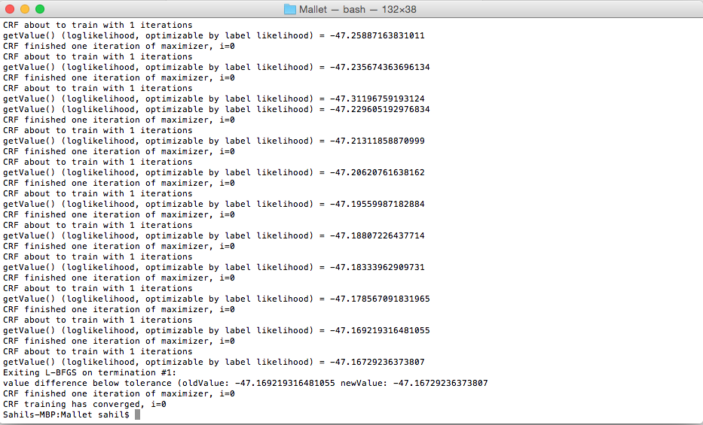

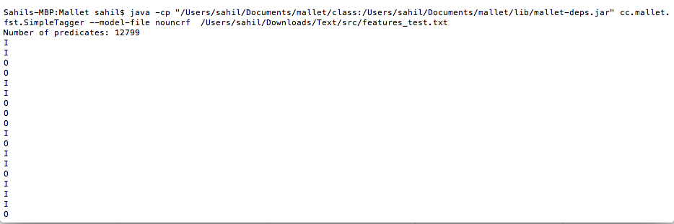

Precision = 99.95692

Recall = 99.95692

f_measure = 99.95691

Tag Accuracy = 99.98959